

**ASSIGNMENT COVER SHEET**

**Student Name: Szabolcs Kovacs & Daragh Walshe**

**ID Number: B00063874 & B00064428**

**Course: Bachelor of Science in Computing (BN104)**

**Year: 2014**

**Lecturer: Orla McMahon**

**Title of Assignment: Assignment 2**

**Due Date: 7. 12. 2014.**

**Date Submitted: 6. 12. 2014.**

The material contained in this assignment is the author’s original work, except where work quoted is duly acknowledged in the text. No aspect of this assignment has been previously submitted for assessment in any other unit or course.

Signed: ________________________________

Signed: _______________________________ Date: ______/______/______

Contents

Abstract 3

Introduction 4

Team Coordination 4

Implementation 5

Web Hosting and Redirection 5

Page Design 6

JQuery mobile Theme swatch 6

Header 6

Content Area 6

Footer - Navigation 7

Home page 7

Blog page 8

Photo page 8

Video page 9

Google Map Page 10

RESTFUL Application Programming Interface (API) 10

WordPress 11

YouTube APIs 11

Flickr 11

Conclusion 12

Appendix – Screen shots 13

# Abstract

The following paper describes the development of a mobile website. It was built as a group effort with the work divided between two team members. It is provided as a mobile version of an existing website, but was targeted for viewing on mobile devices with their reduced screen size and limited processing capabilities. The paper sets out to describe all of the various methods employed to build a website of this nature which includes media feeds from various external websites, with content brought into the mobile device only when required by the end user.

# Introduction

This project has been undertaken in part fulfilment of the requirements for a BSc. In Computing at the Institute of Technology, Blanchardstown in Dublin, Ireland. The requirement is to produce a mobile website. This site will be the mobile version of the Dunkin Divers website, which was built as Assignment one for the Rich Web Applications module of the above mentioned course. It is a group project which has a team of two students: Daragh Walshe and Szabolcs Kovacs. The following paper describes the project development from the initial design, which was based on the main website, to the completed mobile site live on the internet.

In addition to the site being designed for mobile browsers, there was also a number of additional requirements such as

* Including the google map feature from the main site.
* A page to display a blog fed in from a separate WordPress blog site.
* The ability to show images from a separate Flickr account.
* A feed of videos from YouTube which can be played on the mobile.

# Team Coordination

The structure of mobile sites, where many ‘pages’ are actually contained in the one HTML document, with the separate pages delineated by links to internal tags, can lead to certain problems for team development, as two people can be working on the same file simultaneously. It was apparent at a very early stage that a system would be needed to avoid coding conflicts. This was achieved by agreeing that either person would only work on only one ‘page’ section at a time. It was also useful to set up a structure with separate CSS and JavaScript files for both developers. With this method, when the main code was added to incrementally, it was very easy to track down any conflicts, as they were usually to be found in these small sized development files. Most problems were caused by the CSS as there is quite a lot of it used between the two team members working on top of the jQuery mobile framework which depends on both structural and styling CSS libraries.

# Implementation

The website was built using HTML5, CSS, JavaScript and the jQuery-mobile library as its main components. As with the previous website a Project directory was created with appropriate sub directories for different file types and images. It was also decided to keep the FontAwsome plugin as it is very light.

The use of different media API’s (Application Programming Interfaces) were necessary to implement the requirements for the flickr, YouTube and WordPress blog. The method is similar for all three, where a call is made to a remote site to obtain the data in the form of a ‘json’ object. This object can be displayed to the console for examination in order to call the required items into the web-page with the use of javascript.

Many features and elements were developed by using JQuery mobile framework which provides a rich user experience graphical user interface for visitors.

# Web Hosting and Redirection

To give the sites a home both team members set up a web hosting account. First the main diving site was set up on the daragh.co domain. A sub domain was also created on the same server with the address of http://mobile.daragh.co and this was used to host the mobile version of the site. A few different methods were tried before settling on the use of a cookie in the head of the index of the main site. This cookie will execute before any other scripts and check the header of the connecting device. If the device is identified as a mobile or if its screen width is less than 699 pixels, it is re-directed to the mobile sub-domain. The code for the cookie was found at: http://moobifly.com/faqs/

A separate domain was also set up at http://sabi11.co to host the blog which is fed to the mobile device on demand.

The main website can be viewed at <http://daragh.co>, and the mobile site is located at <http://mobile.daragh.co> . If the main site is navigated on a mobile device, it will be automatically redirected to the mobile sub-domain.

# Page Design

## JQuery mobile Theme swatch

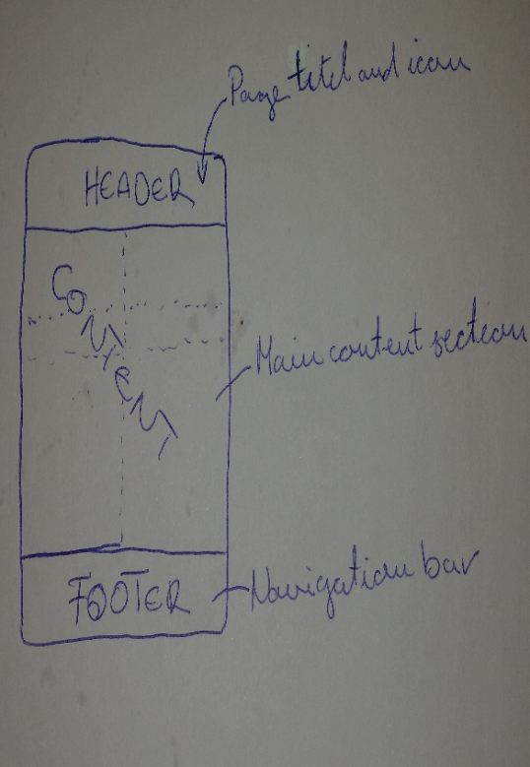

Figure 1. The page layout

This was very easy to create on the jQuery website by simply dragging colours into the provided sample mobile page. It is a nice method to see how a page will look when it is created. For the mobile Dunkin Divers site we used the main website to capture colours with a colour-picker program. This method allowed for a nice continuity between both sites. As up to 26 colour schemes can be incorporated into the one file it was decided to create a total of four different schemes, labelled a, b, c and d to provide some contrast in the site. Not all were used in the end, just the middle two: b and c. Figure 1 shows that each page is divided up into three sections, header, main content area and footer.

## Header

This is the top section, it was adopted form the original site with the size of 100% width and 80px height. However, the original site consists of eyesight user experience feature, that feature was not build into the mobile because the mobile operating system capable to zoom in or zoom out of its screen. It contains a page information along with both sides of an icon. Figure 2.



Figure 2. The header of the mobile website

## Content Area

Where the main page content is displayed, it is a 100% width, auto height block, its content varies on every page to support a wide range of smart devices. The content will be described in greater detail in the next section.

## Footer - Navigation

The navigation bar is displayed as a horizontal bar at the bottom of the page. We used the maximum number of five buttons for the main pages of the site. All other pages are reachable from these five main pages which can be considered as the backbone of navigation within the site. As with a lot of HTML5, data-attributes are used within page ‘div’ tags, to define a list of hyperlinks as a navigation bar. However it needed a different method to highlight the current page button than we had previously used, using jQuery pre-defined classes as shown:

## Home page

Content of the home page was slightly changed, under the header the business logo and the welcome message were placed. Next, there are two buttons: one contains details about the business and the other consists of social links such as Facebook, Twitter and Google+. Below that the original website’s contents were placed into a collapsible widget. As figure 3 shows this container is an expandable collection of buttons which provides a show/hide functionality.

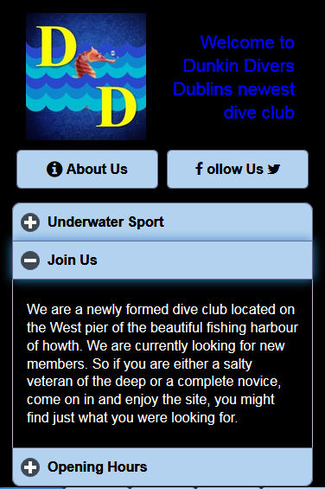

Figure 3. The expandable JQuery show/hide feature

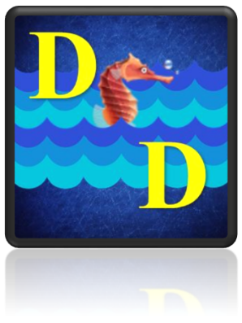

Figure 4. Icon design

Icon Design

A simple design which can be used as an application button if desired.

## Blog page

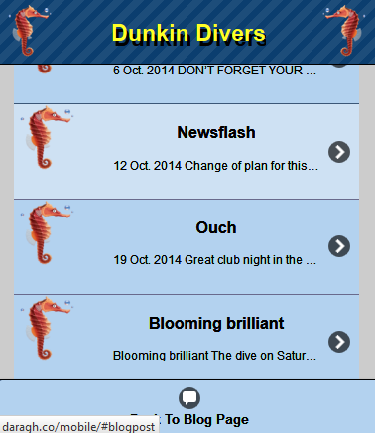

Figure 5. The blog page of the mobile website

This page consists of the same features as a home page except it has a blog button. That button is linked to the Dunkin Diver blog site thus all the latest stories can be automatically fetched into the mobile app as figure 4 shown below.

## Photo page

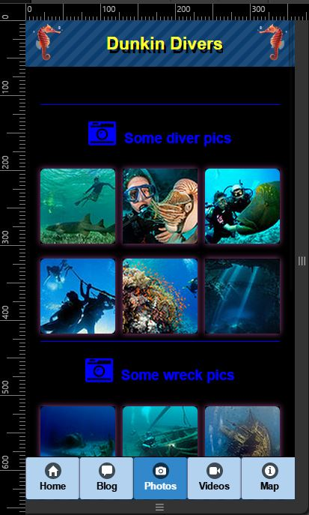

Figure 6. Photo page

This page was created with pictures which are brought in from the flickr website. First the page was laid out with an empty div with a three column grid in the content area to feed the content into. Next a flickr account was set up and the images from the main website were uploaded and tagged. All the images were given a main tag of ‘dunkinPhoto’ and an additional tag of either ‘divers’, ‘wrecks’ or ‘creatures’ to allow us to sort them out later.

## Video page

Video page is connected to the YouTube video gallery using a Google APIs version 2. The page contains thumbnails of videos which provides a link to play YouTube videos without leaving the website. The thumbnails and video page are shown in figure 6.

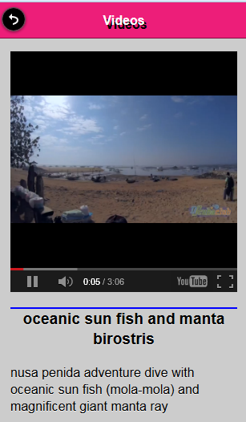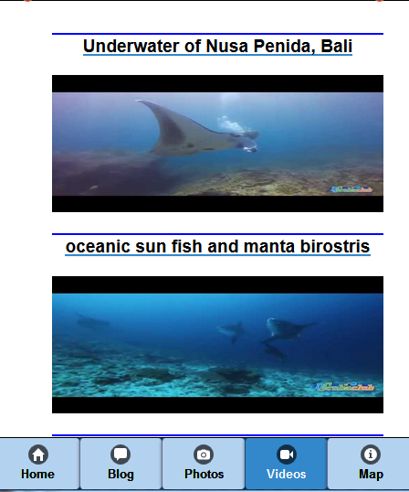

Figure 7. The first screenshot contains the thumbnail, the second the playground of the YouTube video.

## Google Map Page

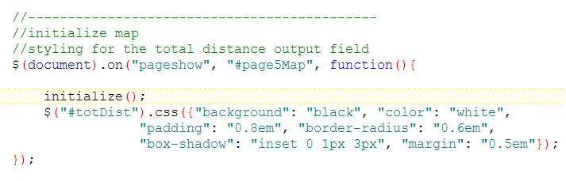Importing the map code from the main site was *mostly* straight forward, with a few minor changes. The layout of the divs which acted as containers for the map and directions panel needed to be structured in a vertical manner to suit the mobile screen, with the directions panel placed below the map. The map marker was returned to the default map-pin style. The pop-up contents were also edited to look better on a small screen. The biggest problem faced was that the map would not render fully on first loading, although it would fully display on a page refresh. On investigation it was found that the cause of this was due to the order in which page elements are rendered, with this multi-page mobile site structure. This is true of a lot of JavaScript and jQuery events. The problem was fixed by calling the map initialise code on the ‘pageshow’ event, shown below with the JavaScript injected styling for the total distance output field.

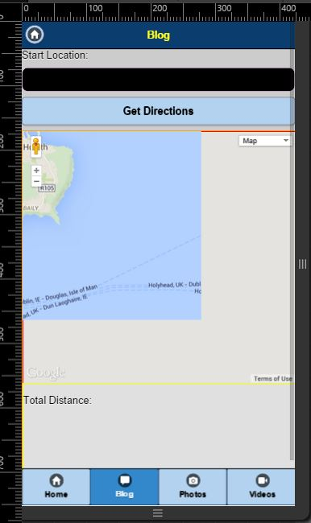

Figure 8.Problem rendering map

## RESTFUL Application Programming Interface (API)

This stands for Representation State Transfer. The main feature of the API is to facilitate communication between two websites by using hypertext transfer protocol. Moreover, details of heavy web content such as video or images are converted into JSON form. Therefore the RESTFUL WEB service provides a light weight data fetching method over the internet.

# WordPress

WordPress is one of the most popular content management system (CMS) among bloggers and developers. The following steps were performed to setup a blog

1. Upload all the content of the WordPress folder by using FileZilla file protocol service.
2. Create a database and link to the WordPress.
3. Create wp-config.php file.
4. Set up administrator information such as login name and password
5. Login into the Admin Panel
6. Create a new blog post to add new content
7. Adding a RESTFULL, using search option in the plugin section

# YouTube APIs

The YouTube APIs were developed by Google. The latest version is the v3, however in this project the version 2 was used. The API provides a solution to build a dynamically a customized link list of videos on the mobile website by using a combination of technologies like JSON, JavaScript, cloud service and JQuery. The user can access and watch each video on the mobile website by clicking one of the thumbnail of the video. As a result, the user can receive a fast and reliable video features on the website without loading a YouTube videos.

# Flickr

A call to the flickr API was placed in Javascript tags in the foot of the document. The parameters of the flickr account id, the tags of the photos to retrieve and the format are passed with the request:



Next step is to call some javascript on the pageshow event. First the json object is cycled through and the pictures are separated into three groups of six according to their tag type, before being built into an html fragment. This was necessary as every time they are sent from the flickr site they seem to arrive in a random sequence. Finally some styling is injected into the page with more JavaScript.

The final step was to create a separate sub-page where a larger image is displayed when the user clicks on a thumbnail image. A separate colour scheme and page transition are used to separate the feel from the main page navigation.

# Conclusion

The aim of the mobile web development assignment was to transform an existing website into a mobile environment, using a combination of various programming techniques and tools. The development process contains a great number of challenges such as repositioning content, using JQuery mobile, working as a team and adding several different APIs. Finally the group were able to adopt these new technologies, which are essential to build a professional website for clients.

# Appendix – Screen shots

The following screenshots are displayed on the google chrome browser with the viewport set to emulate the iPhone6 mobile platform.

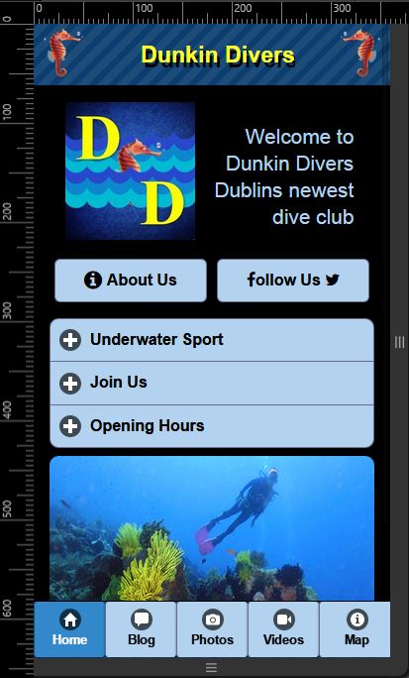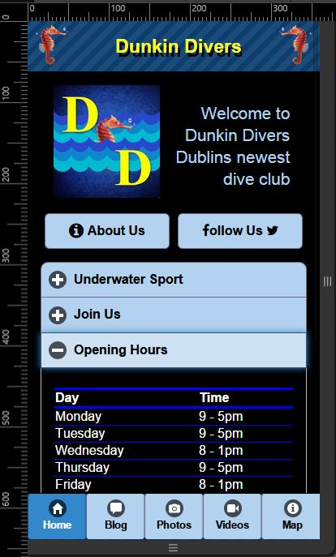

Figure . Homepage screenshots

Figure 10. Blog page and sub-pages

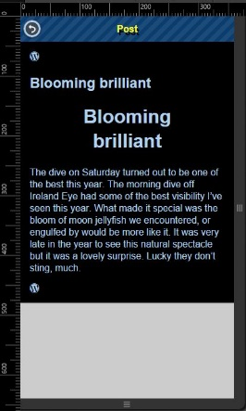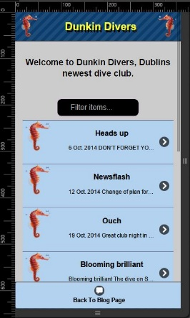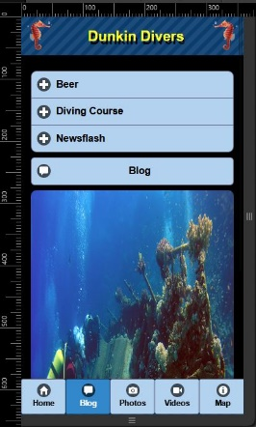

Figure 11. Photo thumbnails page and photo display

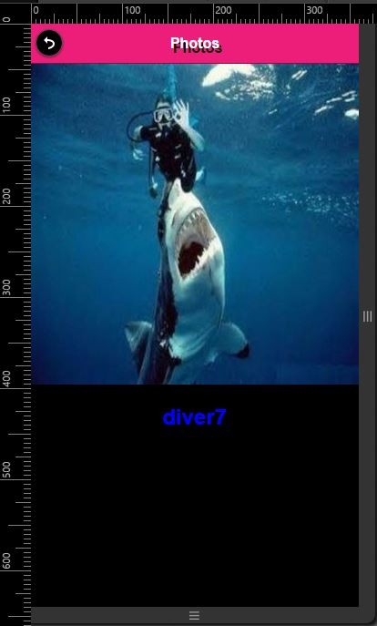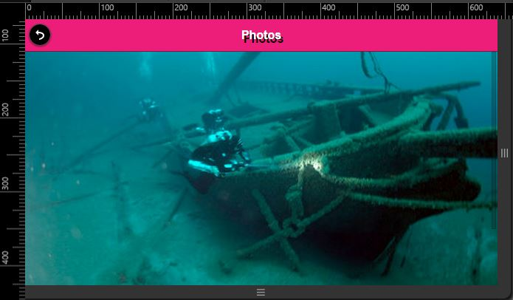

Figure 12. Videos page, with YouTube videos

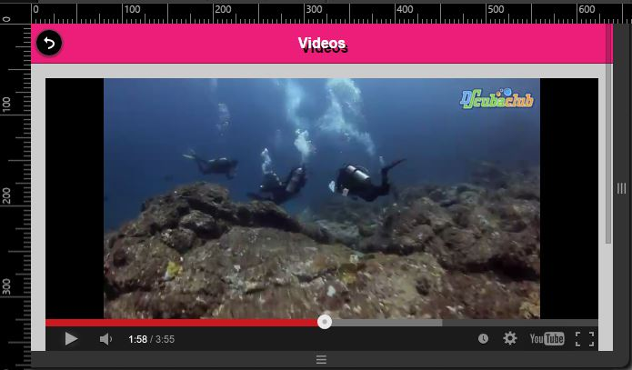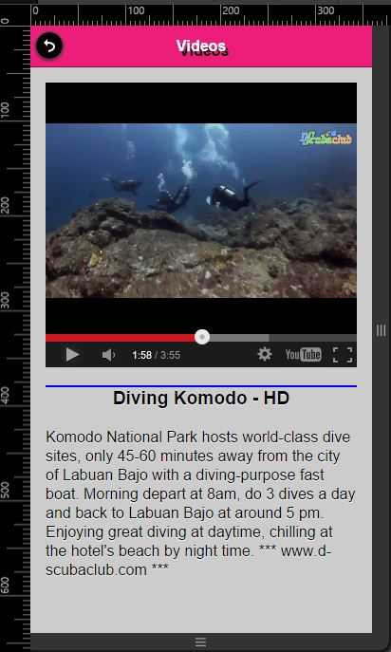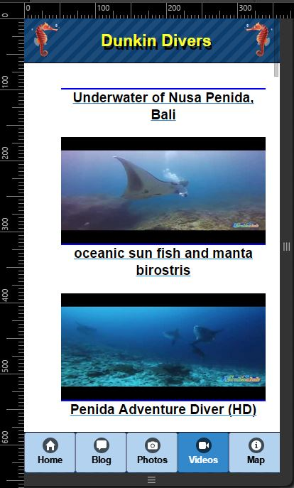

Figure 13. Map page showing directions panel

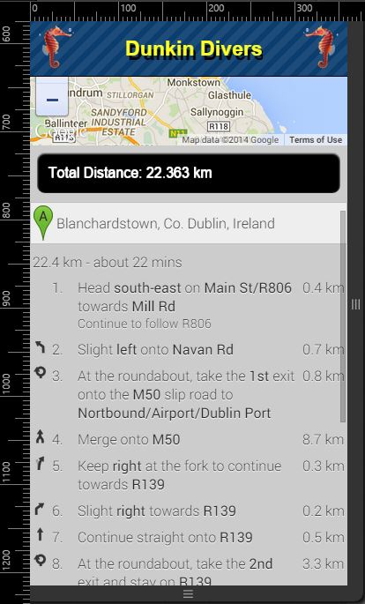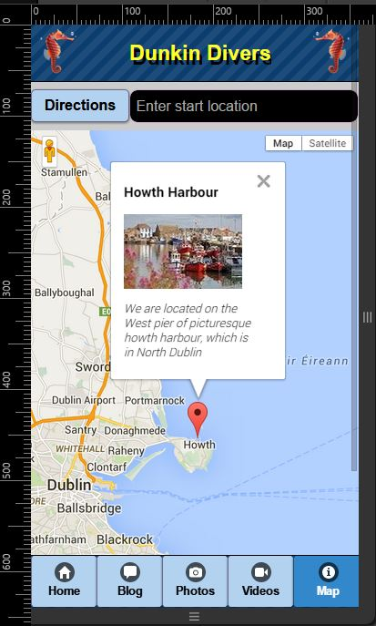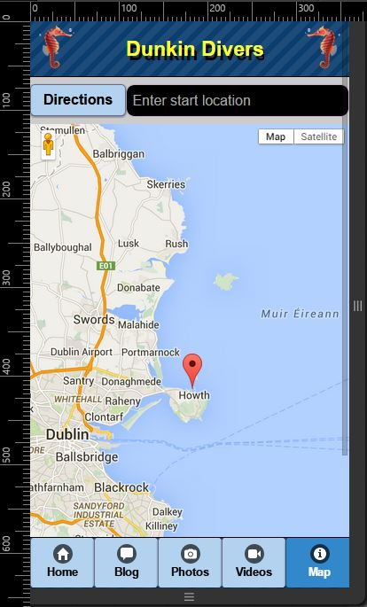

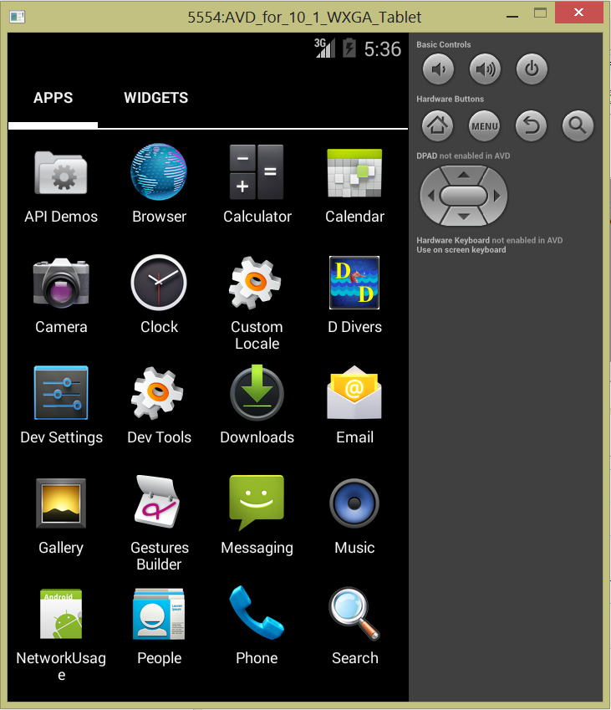

Figure 14. App icon on an emulated android device.